**7 Sept 2018** **The Weekly Bulletin of Rotary Club of Kathmandu Mid-Town** **bc-1.9/018**

|  |
| --- |
| C:\Users\Public\Documents\RIP T1819_EN.png |

District: 3292 Web:www.rotarymidtown.org.np Club Id: 26776

**SEPTEMBER IS THE BASIC EDUCATION AND LITERACY MONTH**

**Basic education and literacy is one of Rotary’s six areas of focus.**

**Basic education :** The range of educational activities taking place in formal and informal settings to meet basic learning needs until completion of secondary school or its equivalent.

**Literacy :** The ability to read, write, engage in critical thought, understand spoken and nonverbal communication, and use dominant symbols appropriately.

Club Meeting # 1455 on 31 August:

AG Bijaya Mallapaty, Past President of Rotary Club of Patan, was welcome by President Jo. He missed the Club Assembly meeting of the Club last week. He made up by visiting the Club’s meeting this day.

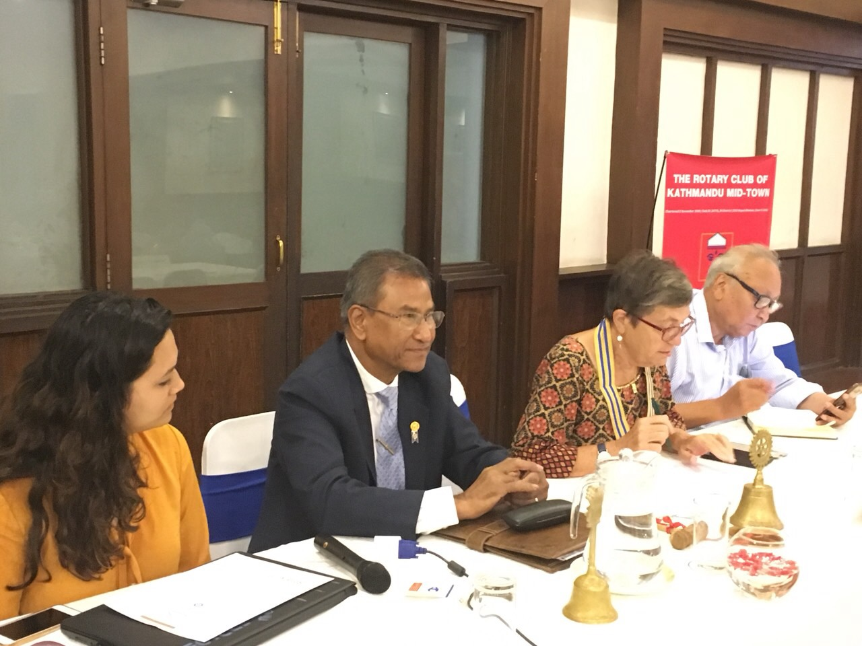

AG Bijaya Mallapaty addressing the Club members in the meeting.

Guest speaker Aayushi KC talked about

what inspired her to be the social entrepreneur

working for trash management, her focus

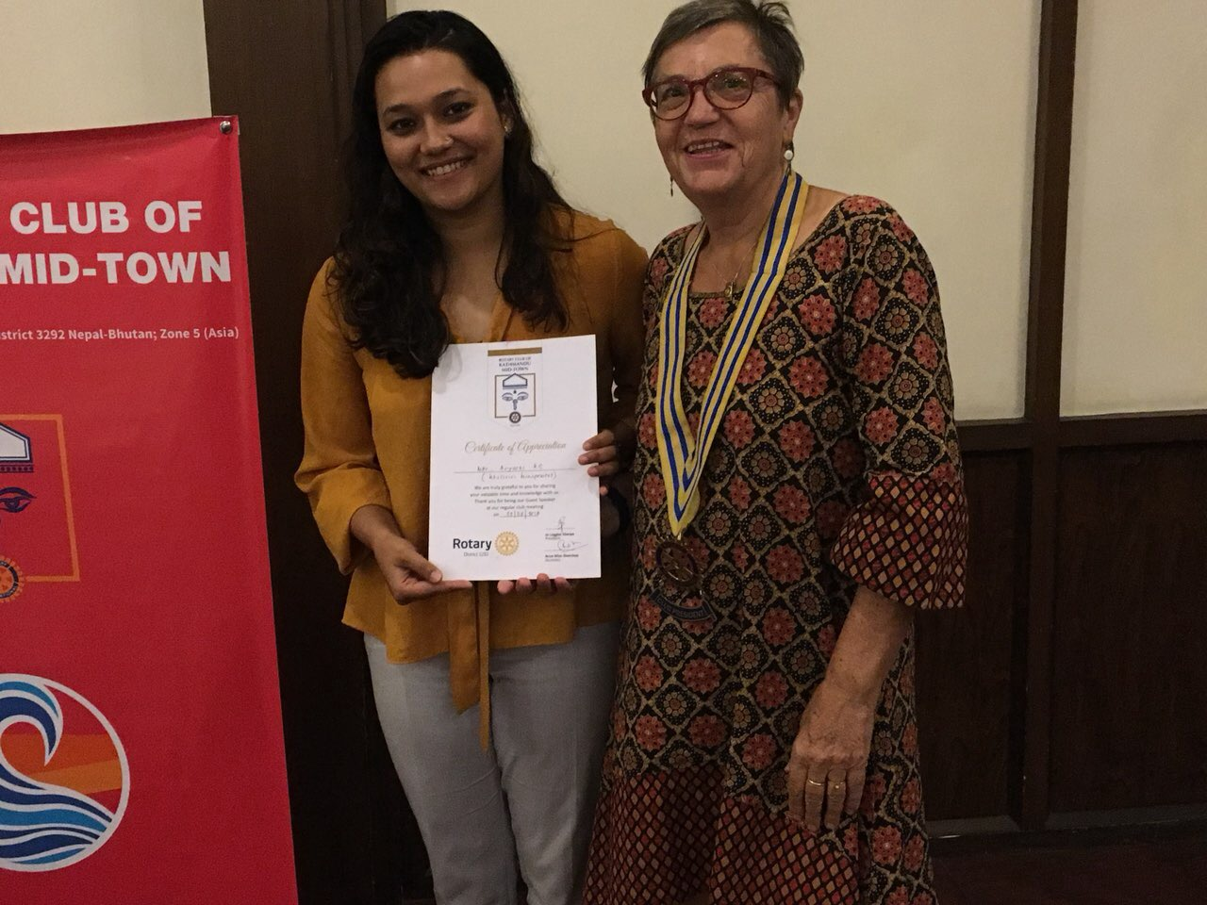

Guest speaker Aayushi KC receiving a certificate of appreciation from Club President Jo

on ***khaalisisi***, empty bottles. She is the founder

and CEO of Khaalisisi Management Pvt Ltd,

one of the most modern and leading waste

management companies in Nepal. It connects

more than 13,000 recyclable waste-buyers

to waste-sellers, helping to substantially

increase the diversion of recyclable materials

away from landfills. She is also active in

trying to change public opinion when it

comes to the importance of recycling and

the waste-collectors who facilitate it. Being

a woman in a country like Nepal is obviously

a challenge, and for her this is what motivates

her to do better.

The **Forbes** chose her as one of the top 30

under ‘30 social entrepreneurs in Asia’ in 2018.

# Weekly Meeting/Program Schedule:

|  |  |  |
| --- | --- | --- |
| Date | Program/ Speaker | Topic of Presentation |
| 7 September | Ms Pawana Shrestha | Etihad Guest Loyalty Program |
|  |  |  |

Friday Meeting: 7 Sept

Pawana is Country Manager of Etihad Airways in Nepal.



She is a talent in marketing!

She started her career with Gulf Air

Galileo, a name in CRS (computer reservation system) saw the marketing talent in her

and grabbed her offering the position of Country Manager. And she proved her

talent as expected.

Giving a best performance in Galileo in a short time, she again jumped over to airline

career in 2011. She joined Etihad Airways, she could not give up the offer she was

given, a very attractive profession, a glamour in airline career.

She is also President of Nepal Women Global Network, besides being member in

various other professional associations.

Guest speaker, Ms Pawana Shrestha

**Club Information: Visiting Navakiran Orphanage**

PP Paras SJB Rana requests club members to take part in a program of visiting Navakiran Orphanage which has been scheduled for Saturday,15 September.

The Navakiran Orphanage children have planned for a special program on that date.

This will be a great opportunity for Club members to see the difference our club has been able to make to improve the living standards of the needy orphanage children with the support of many other International Rotary clubs.

It will also be an special fellowship opportunity where our Club members will have a firsthand observation on the project that has been successfully carried out.

Community Service Project committee members are specifically requested to kindly participate and give in their valuable suggestions to make this event fruitful and memorable.

**Be The Inspiration**

For RI President Barry Rassin, “Rotary is not only a

model but an inspiration. It shows us what is possible,

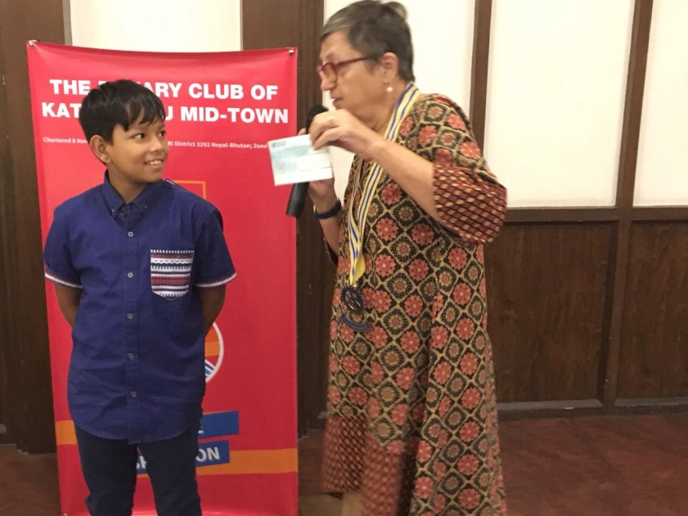

President Jo receiving a cheque from Adhir

inspires us to reach for it, and gives us a path to act -

and to *Be the Inspiration* to our world.”

Exactly for our fellow Rotarian Govinda Chipalu, Rotary

has proved to be an inspiration to inspire his son Adhir

decide to share his birthday happiness by contributing

whatever gifts (not in kind, but in cash) received from

family friends, relatives and from his own friends to an

orphanage! It’s indeed difficult to inspire children to give

away their money, that too collected in his/her birthday

celebration. It’s their money earned on a special day!

Govinda made it by inspiring (or by coercion?) Adhir to

give away his money!

Adhir decided to donate his money to an orphanage.

During the Club meeting President Jo, to everyone’s

surprise, invited Adhir to the rostrum and handed over

microphone for him to announce his handing over a

cheque. Then he handed over a cheque amounting to

Rs 50,720 collected on his recent birthday party to

President Jo.

A big applause followed.

**Condolence**

CP Roop Jyoti lost his mother last Monday.



President Jo and all members of Rotary Club of Kathmandu Mid-Town express deepest condolence.

May God gift you comfort and strength at this hard time.

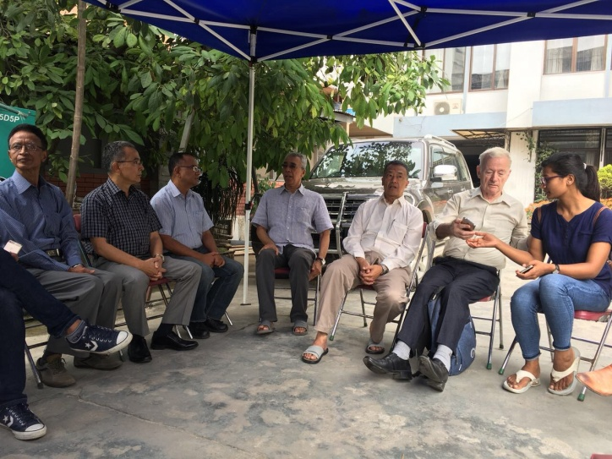

After the meeting Club members visited Roop’s home

to pay a homage.

**A THOUGHT FOR TODAY:** [If your foot slips, you suffer a fracture;](http://www.brainyquote.com/quotes/quotes/b/baruchspin101666.html" \o "view quote)

[if your tongue slips, you fracture someone's faith or joy.](http://www.brainyquote.com/quotes/quotes/b/baruchspin101666.html" \o "view quote)

[That fracture can never be set right; that wound will fester forever.](http://www.brainyquote.com/quotes/quotes/b/baruchspin101666.html" \o "view quote)

[Therefore, use your tongue with great care.](http://www.brainyquote.com/quotes/quotes/b/baruchspin101666.html" \o "view quote)

[Always speak softly and sweetly, and only as much as is necessary!](http://www.brainyquote.com/quotes/quotes/b/baruchspin101666.html" \o "view quote)

**Committee Chairs’ Column:** *(This column is for use by chairpersons of 5 permanent committees: Club Administration, Membership, Public Relations, Service Projects, and the Rotary Foundation)*

**Members’ Corner:** *(This column is for Club members to express anything they would like in matter of Club activities, Club administration, Club issues or on Breakfast Chatter, or on anything else that would be of interest to fellow members.)*

**Photo courtesy:**

All photos from Rtn Shyam R Thapalia. Many thanks !

On Lighter Side:

Teacher: Desmond, your composition on "My Dog" is exactly the same as your brother's. Did you copy his?

Desmond: No, Sir. It's the same dog!

.

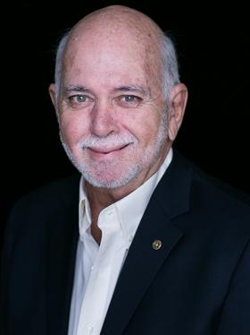

I ask all of you to Be the Inspiration to help Rotary move from reaction to action - to take a hard look at the environmental issues that affect health and welfare around the world and do what we can to help.

**RI President Barry Rassin**

Please send information on club activities, progress reviews on service projects, relevant photos etc to:

BC Editor: RR Shrestha email: rryesrr@gmail.com

## 7 Sept 2018 The Weekly Bulletin of Rotary Club of Kathmandu Mid-Town bc-1.9/018